___________________________
To host
CHILDREN’S AUTHOR GAIL HEATH
Date:________________
Time:__________

Heath, featured author at the 2004 Sundance Children’s Festival in Sundance, Utah, will be reading and signing books. You and your child will not want to miss this event.

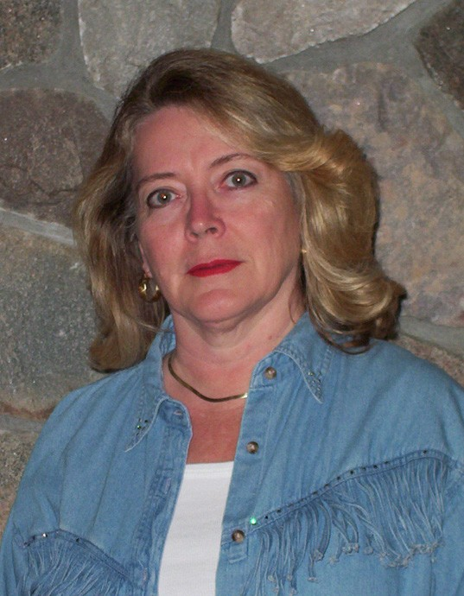

Award winning author, Gail Heath, wears many hats. As author, illustrator, and storyteller, she takes her craft into many settings teaching and entertaining her audience and reader. A public school teacher for many years, Heath is at home discussing her work in the classroom as well as presenting before community and religious groups.

Author and illustrator of the picture book Inside me, Sometimes, and elementary reader, No Time for Fishing, Heath has had articles, poems, and stories published in national and regional magazines as well as newspapers—and was recipient of a Santa Barbara Writers Conference Award.

Children of all ages welcome----even grandparents.
Books will be available for purchase.
NO TIME FOR FISHING (hard cover) $14.95 + tax INSIDE ME, SOMETIMES (paperback) $ 6.95 + tax

